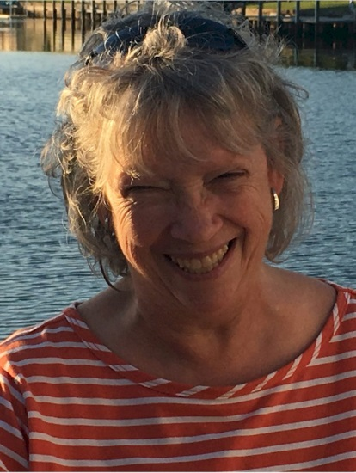
Lynn Sullivan

Notable – Accomplishment/Contributions

6509 Yost St. NW
Canton, Ohio 44718
Phone (330) 323.4673
E-mail LynthiaRae@gmail.com

Balloon Event Officiating Experience
- Chief Scorer
  - 1st Mexican Nationals Competition 2011
  - 31st Brazilian National Championship 2018
  - BFA Great Lakes Regional Championship, Findlay OH 2017 – 2018
  - BFA Great Lakes Regional Championship/Michigan State Championship
Frankenmuth MI 2007 - 2008
  - BFA Great Lakes Regional Championship/Ohio State Championship Middletown OH 2003 – 2015
  - BFA Ohio State Championship Middletown OH 2016 - 2017
  - BFA Southwest Regional Championship Albuquerque NM 2015 - 2016
  - BFA New Mexican State Championship Albuquerque NM 2017
  - The Great Wadsworth Balloon Festival, Wadsworth OH 2001 – 2002
  - New York State Festival of Balloons, Dansville NY 2006 – 2007
  - Ashland BalloonFest, Ashland OH 2008 - 2011
  - Bluegrass Balloon Festival, Louisville KY 2008 - 2010
  - Pro Football Hall of Fame Festival Balloon Classic, Canton OH 2007–2015, 2021-2022
  - Thurston Classic, Meadville PA 2013 – 2015, 2017 - 2019
  - Blossom Time Balloon Festival 2003 – 2005
  - Old West Balloon Fest, Scotts Bluff NB 2018, 2020
- Deputy Scorer
  - US TEAM National Championship, Shreveport LA 2021-2022
  - BFA US National Championship, Scottsbluff NB 2019
  - BFA US National Championship, Shreveport LA 2016 - 2018
  - BFA US Women’s National Championship, Albuquerque NM 2016
  - 20th FAI World Championship Battle Creek MI 2012
  - BFA US Nationals and International Challenge (Pre-Worlds) Battle Creek MI 2011
  - BFA US National Championship, Battle Creek, MI 2009 – 2010
  - Pro Football Hall of Fame Festival Balloon Classic, Canton OH 2016 – 2019
- Technical Scoring Officer and Measurer
  - 24th FAI World Hot Air Balloon Championship, Murska Sobota 2022
  - BFA US Women’s National Championship, Brookfield MO 2019
  - BFA US National Championship, Anderson SC 2008
  - Field of Flight, Battle Creek MI 2003 - 2004
  - NABA Nationals Waco Tx and Baton Rouge LA 2004 – 2007
  - Albuquerque International Balloon Fiesta 2015 - 2017
US Balloon Club Affiliations
- Balloon Federation of America member since 2008
- BFA Hot Air Competition Division (HACD) member as an Official since 2008
- Northeast Ohio Balloon Pilot’s Association member since 1997
Awards
- NOBPA President’s Award 1998
- NOBPA Safety Award 2004
- NOBPA Spirit of Annie Award 2018
- The Kinnie Gibson Sportsmanship Award 2019 (shared with Maury)
Safety Seminar Organization - Served as Co-Chairman of NOBPA Balloonowledge Safety Seminar 2002 - 2004

I was introduced to the world of competitive ballooning in 1998 as Crew Chief for my (now) husband Maury Sullivan. I have served at competitive events since then in various capacities including organizer, staff coordinator, scoring officer, Logger Manager, Technical Scoring Officer, etc.
I had the privilege of volunteering under and learning from some of the best in competitive ballooning including Tom Sheppard, Jim Birk, Patty and Ken Cramer, Debbie Spaeth, Jim Dieball and Georgene Voutila, Bob and Dottie Humbert and I would be amiss not to mention Maury Sullivan. While I trained and certified as an observer, my experience has been in electronic scoring from the start.
In 2008, Maury and I traveled to Houston, Texas to train with Mike Gilligan on his BFA Scoring Program. I have been privileged to work and mentor with Mike since. I am experienced as well using the BFA Logger Manager Program, BFA Declaration Phone Application and BFA Reckless Flying Application as well as Mike’s new TEAM BFA Scoring Program. As our worldwide competitive technology is changing, I am also well-versed in the WatchMeFly platform as well of the use of the Balloon Live App and sensors. It is exciting to see the entire ballooning world wrapping their arms around the use a common technology.

