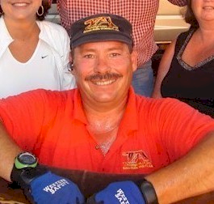
JEFF THOMPSON

Notable – Ed Yost Master Pilot Award

Jeff was born in Ottumwa, Iowa on November 12, 1959. In 1972, at the age of 12, his father took the entire family to the United States National Hot Air Balloon Championships held in Indianola, Iowa just 15 miles south of Des Moines where they were living at the time. There were approximately 19 balloons flying from Simpson College and the crowd was able to go on the launch field to see up close the activities. Jeff became so infatuated with the balloons that for the next several years he constructed tissue paper balloons, heated them over the kitchen stove and went outside and let them go. As he progressed in this activity he was able to use a camp stove butane tank, plastic tubing his mother obtained from a hospital operating room and a homemade burner to tether the balloons and put on demonstrations at his junior high school. When in high school he constructed a 9’ tissue paper balloon with his high school logo and tethered it at football games.
At the age of 15 his mother took him to an outdoors show at Vets Auditorium in Des Moines where an Indianola balloonist, Phil Gray, had his balloon inflated. Jeff spent the entire time at the show talking to Phil and was convinced that he could someday learn to fly balloons. After realizing his determination, his mother and father agreed to talk to Phil and to learn more about the activity. After much discussion and learning about the regulations and process of obtaining a license, his parents agreed to allow him to take pilot lessons. Jeff had saved enough money from a paper route and other part time jobs to pay the $1,000.00 required for his pilot training. He obtained his student license (copy attached) on December 29, 1975. He had completed his training before his 16 birthday and was authorized and soloed (copy attached} on October 17, 1976. He had his check ride and obtained his private certificate (copy attached) on December 5, 1976. The very next year he purchased the “Blue Max” from Phil Gray, the very same balloon he had taken his training in.
He flew at the National Hot Air Balloon Championships in 1977. He was interviewed on National Public Radio as the youngest pilot in the country at that time, along with Captain Eddy Allen (The oldest Balloonist at that time) Jeff and his family also went to Albuquerque that same year. As the youngest pilot flying in the 6th Albuquerque Balloon Festival he earned the nickname “Captain Kid”. He demonstrated a knack for competition when he finished second in the “Tumbleweed Drop”. Don Piccard was on the field and complemented Jeff on the five passes he made in the “Albuquerque Box” in order to make his drop of the tumbleweed. Jeff finished in second place in two other competitions in the event as well. The following year he began competition in earnest and finished 3rd in the National Hot Air Balloon Championships in Indianola. That year he also won the Second Annual Pershing Balloon Derby, the BFA Regional Championships, in Brookfield, Missouri. That led to competition at a number of events in Iowa and the Midwest. In 1978 Jeff was ranked as the #5 pilot in the United States at the age of 18.
In 1981 he moved to Florida where his ballooning activity took a back seat to his work although he started building and renting cold air inflatables in 1986. He was able to obtain his Commercial license on April 2, 1990 (copy attached). In 1990 he moved to Flint, Michigan and began working for US Hall of fame member Denny Floden, Capt. Phogg. While there he flew Tony the Tiger, flew passenger rides and designed and built cold air inflatable balloons. One of his cold air designs, an inflatable car airbag, was mounted on a highway billboard and won a statewide award for uniqueness. Other billboard designs included an inflatable baseball crashing thru a window for an insurance company and a 68 foot tall Christmas tree for Crossroad Village, a 1800s-era lakeside tourist village in Flint. In 1995 he returned to Florida, flying for Rosy O’Grady for 2 years. He then went to work building cold air inflatable balloons for two years. During that time he constructed over 100 balloons including 54 for the Eckerd Drug Store Corporation. Two weeks were spent setting up the balloons at stores in Pennsylvania and New Jersey then leaving them flat on the store roof. With two teams all balloons were inflated over night for the grand opening at business start the next morning.
In 1996 he went to California where he tethered the cast (Craig Nelson, Shelley Fabares, Jerry Van Dyke, and Bill Fagerbakke) for an episode of the TV production “Coach”.
In February 1999 he started flying for Orange Blossom Balloons, the largest balloon ride company in Florida. Orange Blossom Balloons were flying 175,000cf balloons with up to 8 passengers. In 2006 when Orange Blossom Balloons purchased a 240,000cf balloons holding up to 16 passengers he left and started his own company, Thompsonaire Balloons. He enjoyed flying with smaller balloons providing a more personable setting for the passengers.
In 2005 he first returned to competition at the National Balloon Classic in Indianola, Iowa where his ballooning career began. He had a 9th place finish competing against about 90 other pilots. In 2004, at the National Balloon Classic he, as PIC of the Harley Davidson Balloon, along with Dave Sullivan, won the Key Grab event. He finished 14th in the US nationals at Anderson, NC in 2006 and was the BFA State Champion in Florida in 2007, 09, 10, 11, 12 &13. He also won the Carolina Balloon Fest in 2008. He finished top 10 in Indianola in 2012 and finished with a national ranking of 10th in 2013. In 2012 he was awarded the John Russell Spirit of Ballooning Award, one of the highest honors a pilot can receive at the National Balloon Classic at Indianola.
He has been guest speaker at a number of ballooning safety seminars including the FAA Safety Seminar in Lakeland, Florida and the BFA Sanctioned Safety Seminars in Orlando. He has been a member of the Balloon Federation of America since 1958, is a member of the Hot Air Division and is also a member as an event official. He has achieved Level 8 in the BFA Pilot Achievement Award Program. Two of his businesses, Thompsonaire Balloon Rides and Hot Air Balloonist, a web site for balloonist, are corporate members of BFA. In 2016 he was awarded a BFA Directors Award for developing a section in his Hot Air Balloonist web site for use of the BFA Hall of Fame Committee. The site serves as a work area and biographies of notable balloonists stored in this site serve as one resource for the Committee to select possible candidates for inclusion in the United States National Balloon Museum in Indianola.
In his 48 years of flying balloons he has accumulated a perfect safety record with over 6,200 hours and 7,000 flights.

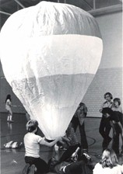

Paper balloon at Jeff's Jr High School
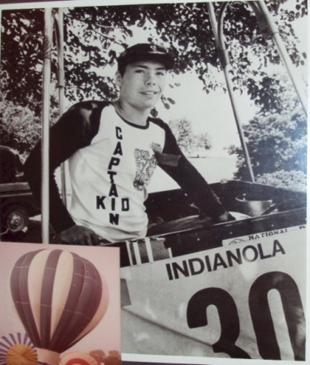
Jeff and the "Blue Max"
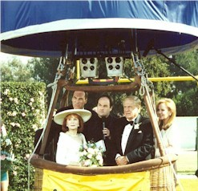
1996 - Cast Members of Coach
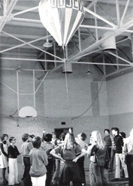
Roosevelt High School Balloon
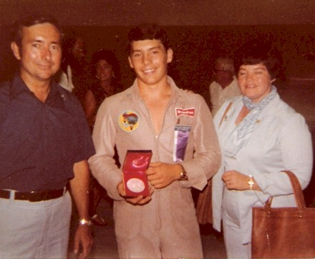

1978 - Jim, Jeff with 3rd place medal, Connie
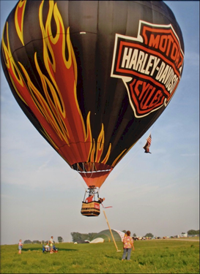
2004 - Jeff (in red shirt) along with Dave Sullivan

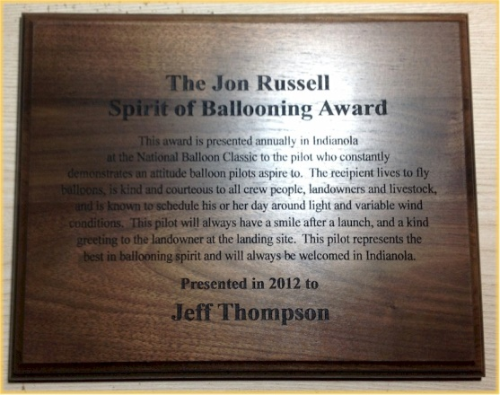
John Russell Spirit of Ballooning Award

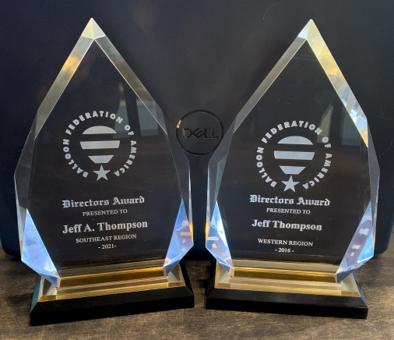
BFA Directors Awards
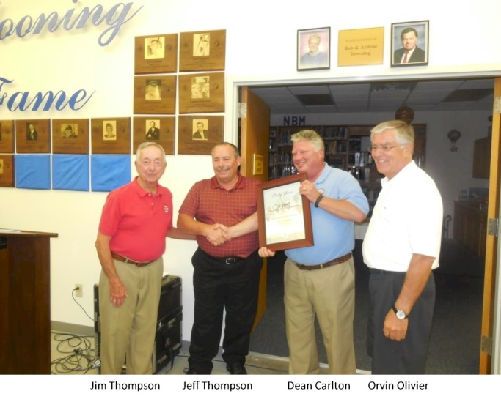 | 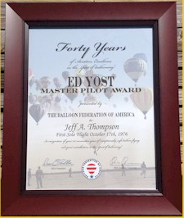  Master Pilot Award

