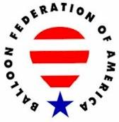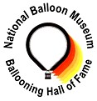

UNITED STATES BALLOONING HALL OF FAME
A Partnership of the Balloon Federation of America and the National Balloon Museum

Candidate Information Form

Date Submitted: March 22, 2025

CANDIDATE NAME: Charlie Markert

Address: 3314 Meridian Drive City: Minneapolis State: MN ZIP: 55422

Telephone: (952) 454-2563 E-mail: cMarkertS@gmail.com

Alternate Contact: Tim Markert (Charlie’s son): 612-990-1322 / tcmEdinaMN@gmail.com

Briefly describe the basis for the submission: Charles Markert was a groundbreaking talent—the only known artist to hand-paint hot air balloon envelopes with extraordinary precision and creativity. His work wasn’t just about decoration; it was about transforming the very fabric of ballooning into an awe-inspiring, one-of-a-kind spectacle.
Working in his restored barn studio, Markert draped 90-foot balloon envelopes over a massive easel and using a fishing pole with a charcoal pencil attached to the end, free-handedly sketched his designs. With a custom paint formula he developed himself, he brought his visions to life using brushes and spray techniques. This would ensure that his work could withstand the harshest conditions of balloon flight and storage. There were no do-overs. Paint mistakes on a balloon’s delicate and expensive envelope were irreparable.—every stroke had to be perfect. After working around the clock for months or a year, it was only upon the first inflation that Market’s results would be revealed.
It all began when General Mills sought a way to elevate their advertising—literally. Balloon dealer Matt Wiederkehr recommended Markert for the job, leading to the creation of the iconic Golden Grahams balloon. That project launched a career that saw Markert hand-paint around 50 stunning hot air balloons, in addition to banners. Many of his masterpieces stemmed from commercial contracts, such as; US West, Tony the Tiger and McDonald’s, but the majority of his projects were personal commissions. He had a unique ability to help pilots showcase their love of aviation while seamlessly incorporating their personal passions into each design. Many of Markert's balloons continue to take flight and remain cherished by their pilots to this day.
Though he never piloted a balloon himself, except for one solo flight, Charles Markert changed the landscape of hot air ballooning forever. His artistry turned the sky into a gallery, blending creativity with the adventure of flight in a way no one else ever has. Perhaps inspiring the special shape designs we marvel at today.

Provide references: The following references are two members of the Hall of Fame can speak to the quality and significance of the achievement, and to the character of the candidate.
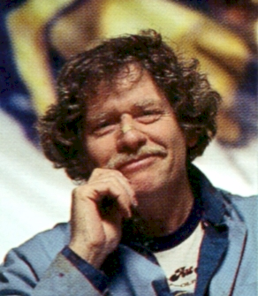

Reference Name: Matt Wiederkehr Telephone: (651) 503-6543 Bobbie
E-mail: bobbiew2004@msn.com
Reference Name: Denny Floden Telephone (941) 928-9337
E-mail: captphogg@gmail.com

PERSON MAKING THE SUBMISSION:

Name: Jim Thompson

Address: 9004 Murano Mews Ct City: Kissimmee State: FL ZIP: 34747

Telephone: (515) 229-5804 E-mail: jim@thompsonaire.com

CANDIDATE HISTORY:
Charlie Markert
Notable – Accomplishments/Contributions
The Artistic Journey of Charles "Charlie" Markert
Born in Brooklyn, New York, in 1936, Charlie Markert’s artistic journey began with a series of moves that shaped his future. After his father’s service in the 8th Air Force, the family relocated to Albuquerque in 1945 and then to Los Angeles three years later. It was in L.A. that Charlie’s formal artistic training truly began.
Attending John Muir Junior High and later Manual Arts High School, Charlie studied under Max Aaron, a teacher trained at the prestigious Art Students League of New York. Under Aaron’s guidance, his students consistently earned scholastic scholarships, and Charlie was no exception. While still in high school, he took night classes at USC with Hungarian artist Francis De Erdely, working on large-scale drawings of live models—an invaluable experience that sharpened his skills. He also earned a scholarship to attend Saturday classes at Chouinard Art Institute.
However, life took a dramatic turn at the end of high school when his father passed away. Charlie enlisted in the U.S. Army as a paratrooper, training at Fort Campbell, Kentucky, with the 11th Airborne Division. Stationed in Augsburg, Germany, he continued honing his craft under the mentorship of a German artist. His wife, Carolyn, joined him overseas, and two of their nine children were born during this time. His final jump was in Beirut in 1958, and later that year, he was honorably discharged in Arcadia, California.

Mastering Large-Scale Art
Charlie soon found work at Pacific Outdoor Advertising in Los Angeles, where he refined his portrait and large-scale painting techniques. Under the mentorship of Italian-trained artists Gino Raffaelli and Fred Ferrari Ari, he spent four years mastering the art of painting intricate billboards, theater backdrops, and ballet scenery. Working with a 4x5-foot board, he drew freehand using a three-foot stick with charcoal attached to avoid tunnel vision. Once the drawings were squared off, he transitioned to painting—first in black and white, then in color—under the watchful critique of the art directors.
Pacific Outdoor was a rigorous training ground, home to some of the industry’s finest classical painters. Many had studied under Ives Gammell in Boston, bringing a lineage of disciplined, classical techniques to their work. The variety of projects—from portraits to landscapes—exposed Charlie to a diverse range of styles and painting methods, preparing him for the monumental works he would later create.

From Billboards to Balloons
In 1969, Charlie moved from Glendora, California, to Minneapolis, Minnesota, to join Naegele Advertising Company. Working under the visionary leadership of Bob Naegele Sr., a patron of the arts, Charlie thrived in an environment that valued artistic excellence.
His introduction to the world of hot air balloon art came unexpectedly. After witnessing hot air balloons at the Minneapolis Aquatennial, he was captivated. His experience in large-format painting naturally led him to this new canvas. In 1979, Matt Wiederkehr of Lakeland commissioned him to paint the Golden Grahams balloon—the first of what would become an illustrious career in balloon artistry. When Charlie saw his first balloon creation come to life at the St. Paul Winter Carnival, he fell in love with the ballooning community. What started as a single project quickly turned into a lifelong passion. He named his company Sky High Art.

Building a Legacy in Balloon Art
Charlie initially rented a warehouse in Minnetonka as his first studio. The Red Barons Balloon Club in St. Paul, recognizing his talent, built him a massive 20-foot-tall by 30-foot-wide easel. That friendship endured for over 40 years.
After a few years, Charlie purchased a six-acre farm in Chanhassen, Minnesota, where he transformed a barn into a dedicated studio. The Red Barons’ easel was moved to this new space, allowing him to work on even larger projects. With plenty of open space to inflate balloons for inspection, it became the perfect setting for his balloon artistry.
When asked why more artists hadn’t taken up balloon painting, Charlie often explained, “My training in large-scale graphics started in high school, and it just made sense. The precision required for 20-foot-tall portraits translated perfectly into painting enormous artwork on hot air balloons. It fit my psyche perfectly.”
Today, many of Charlie Markert’s balloons are still flown and remain beloved by their pilots, a testament to his mastery and the lasting impact of his work. His legacy is not just in the skies but in the hearts of those who cherish the beauty he brought to hot air ballooning.

See additional information on following pages
Website Gallery of Markert’s Work:
https://minnesotaballoonrides.com/art-balloons/
https://minnesotaballoonrides.com/painted-balloon-collection/
https://minnesotaballoonrides.com/markert-media/

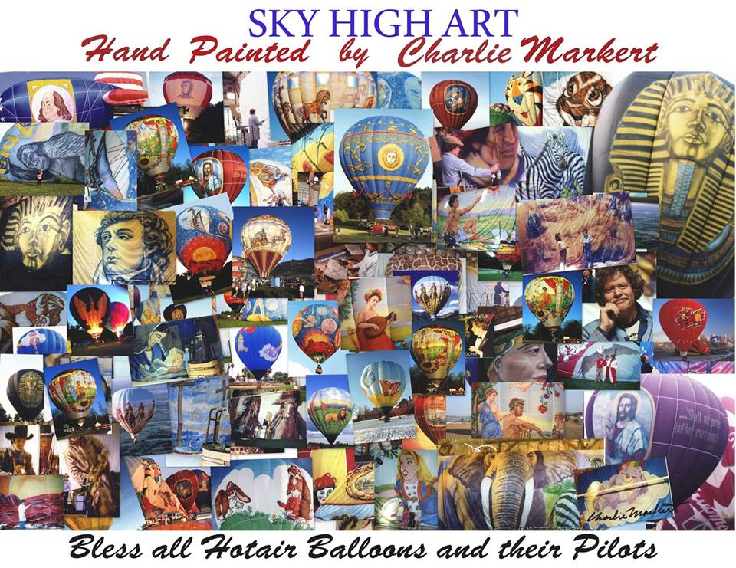

Over the years Charlie painted over 50 balloons for US pilots and pilots throughout the world. Following are some examples of the work that he painted.

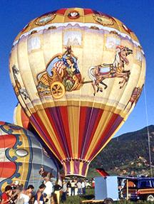

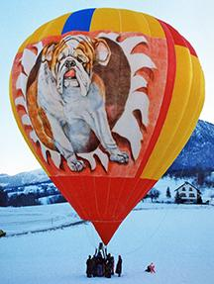

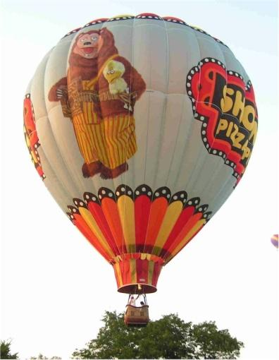

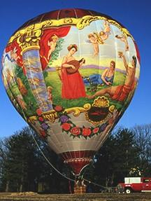

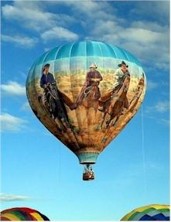

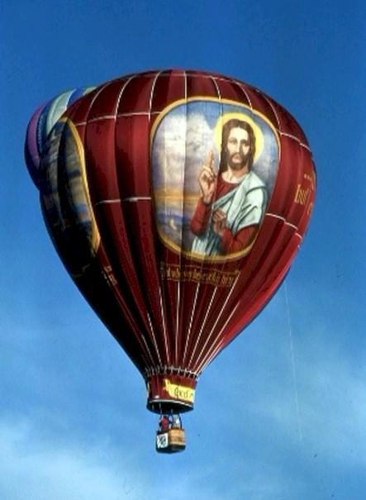

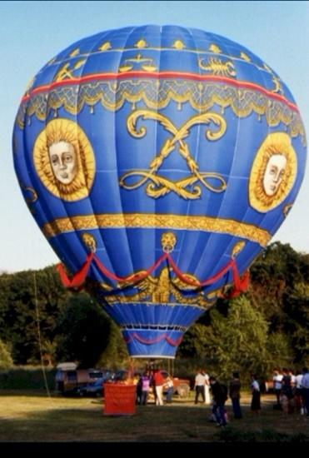

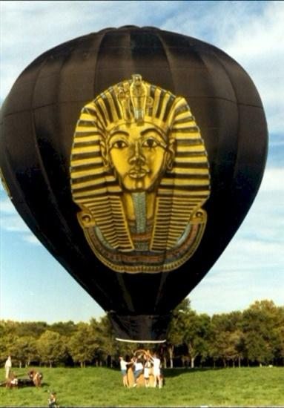

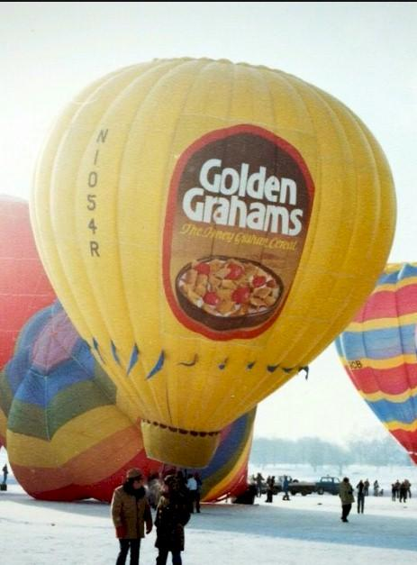

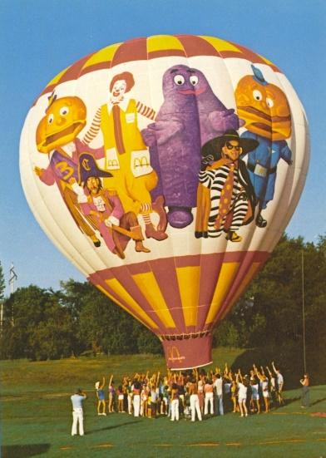



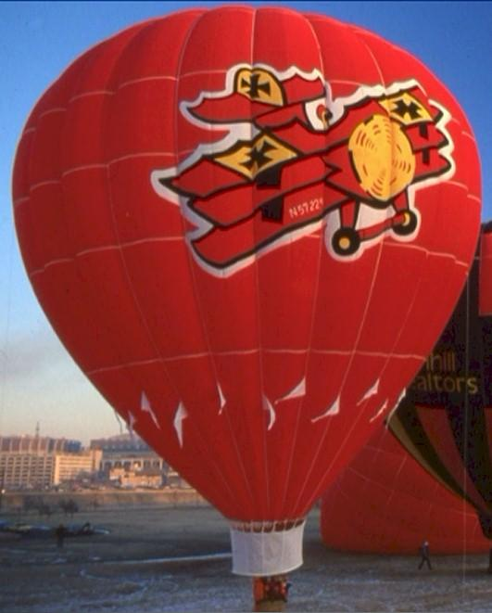


See additional information on following pages
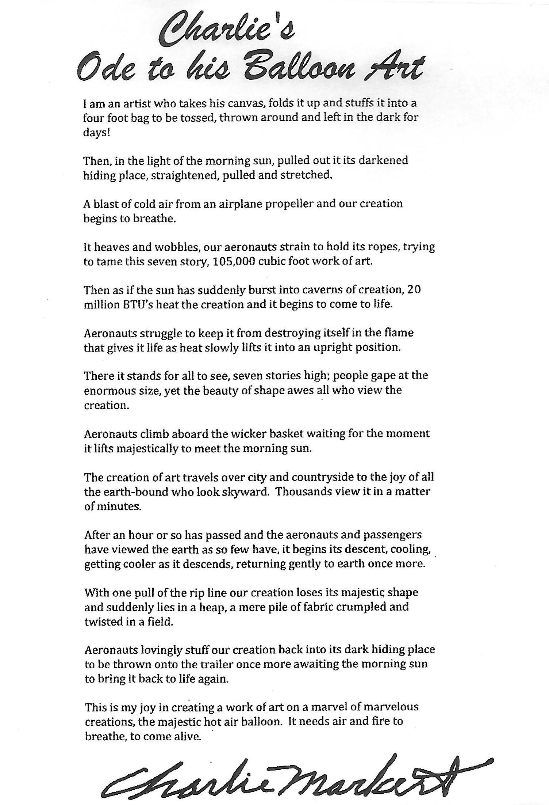
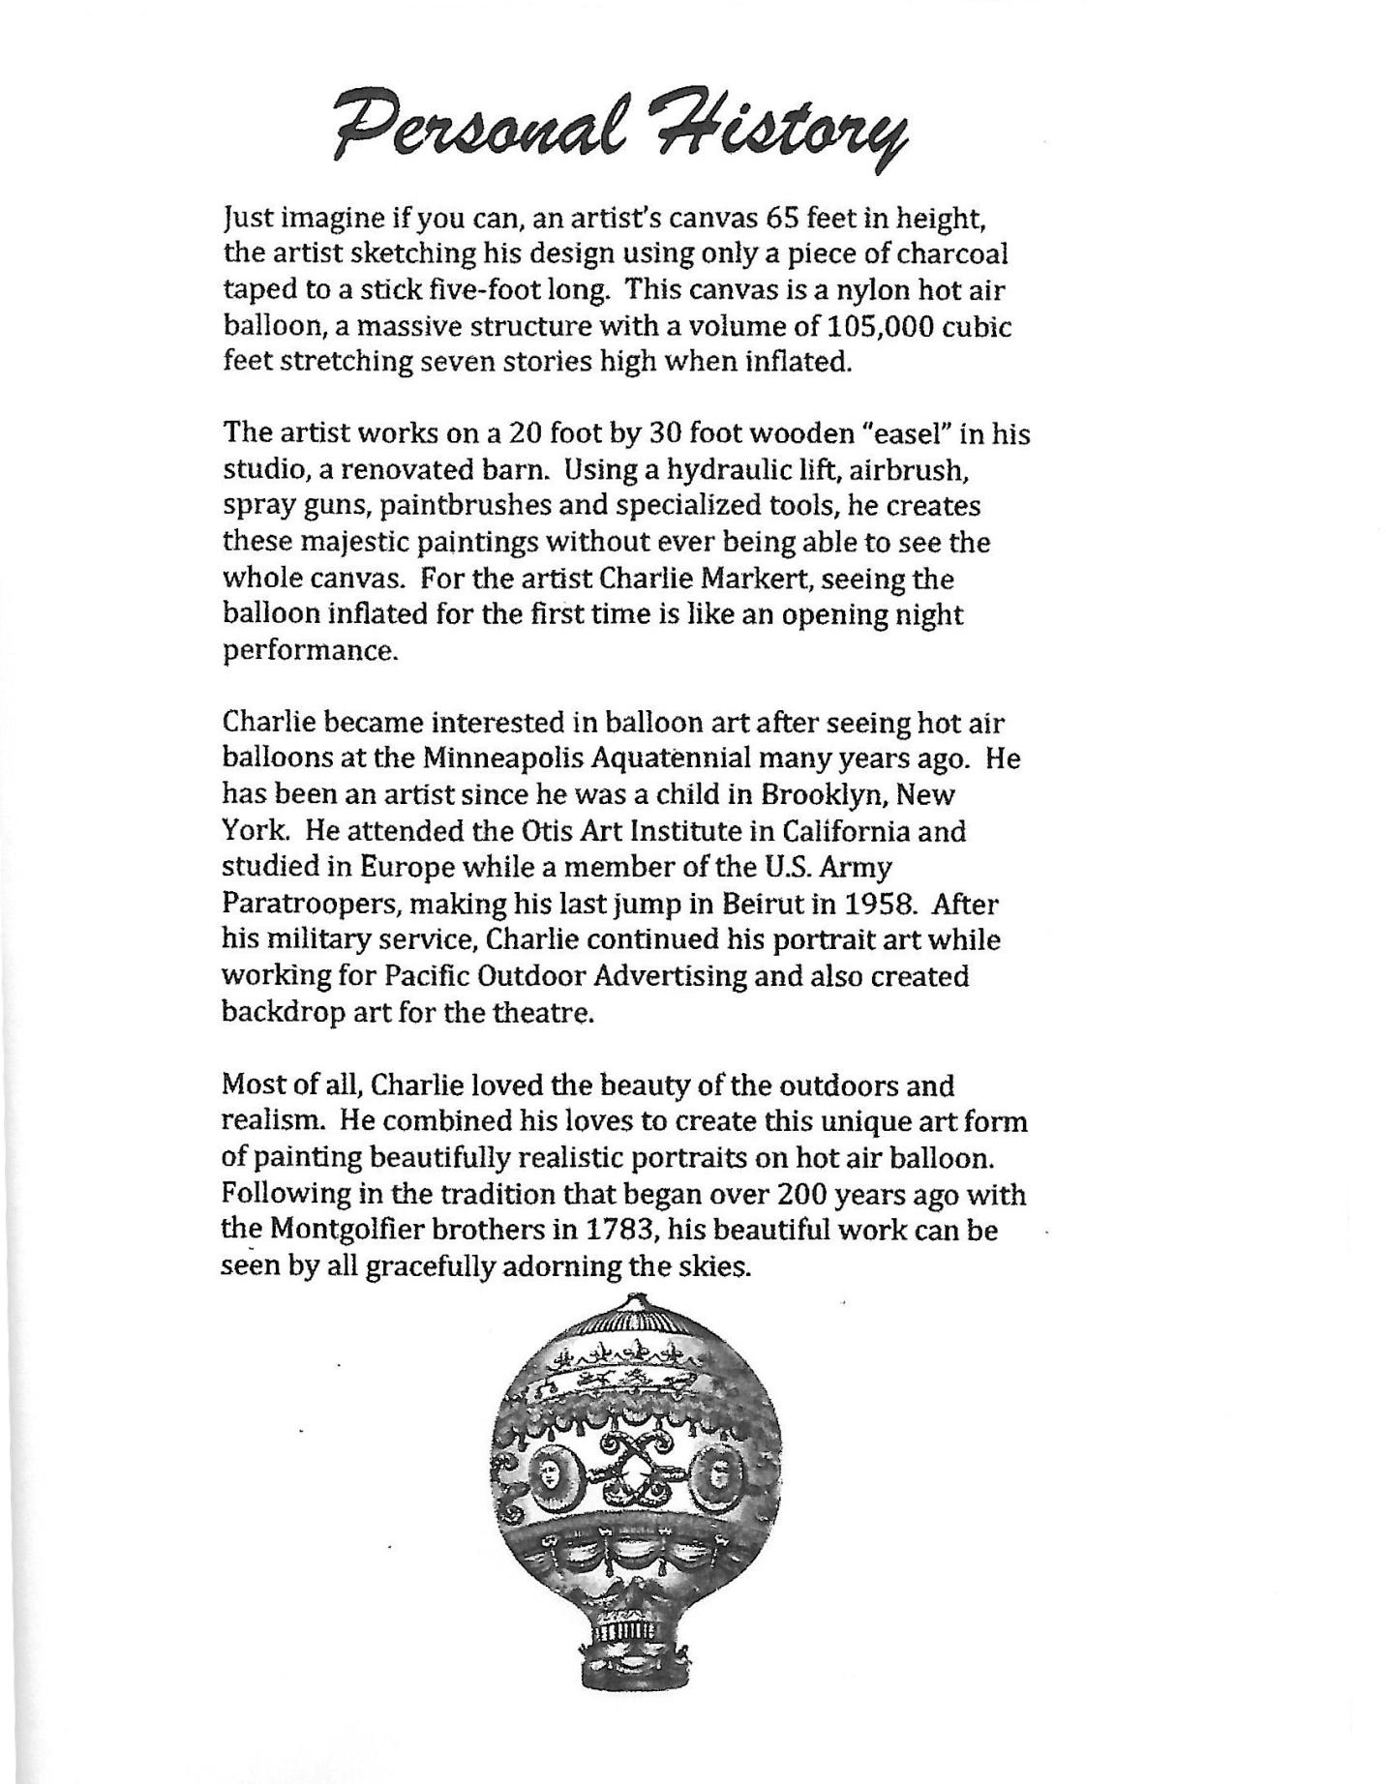
___________________________________________________________________________

Return the Candidate Information Form to:

BFA Awards Chair
Balloon Federation of America
PO Box 400
Indianola, IA 50125

All Candidate information will be kept on file and reviewed annually. This is not an annual submission/receipt Award. The candidate information submitted is gathered and placed on the list of possible candidates to be considered every year for induction to the Hall of Fame. If not selected the year of the submission, it will still be considered every year moving forward. Documents and all candidate information must be received before the HOF Committee meets to review possible candidates. This is usually early of each year to allow enough time for committee review before the BFA Annual Meeting currently held in October. Contact the BFA Awards Chairperson, BFA Office - bfaoffice@bfa.net or (515) 961-8809 - or contact any current BFA Board of Director with any questions. Check www.bfa.net for current contact info.

