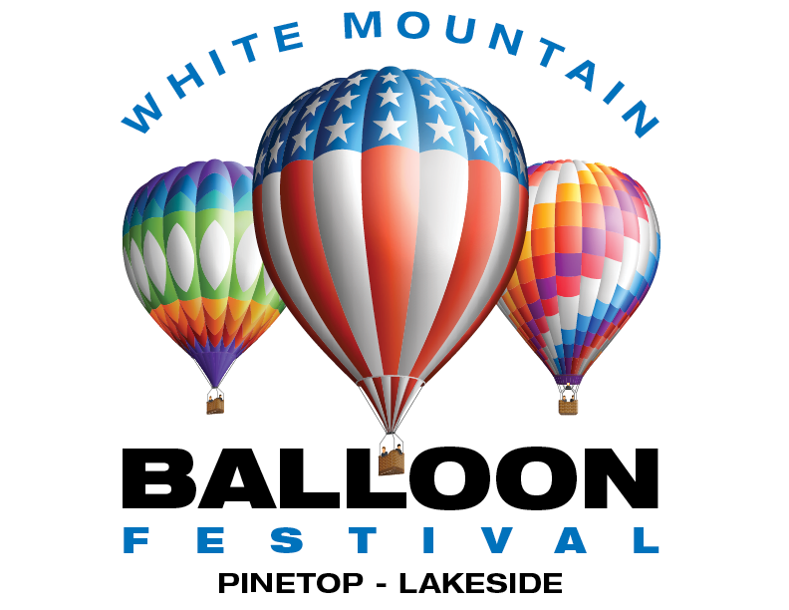

White Mountains Balloon Festival
Fact Sheet:

Dates: Saturday, June 16th, 2018

Hours: 2PM – 9PM

Location: Mountain Meadows Recreation Complex - 958 N Woodland Rd, Lakeside, AZ 85929

Attendance: Up to1,000 fans and spectators are expected to enjoy this outdoor community event.

Events: A single day event to take place on Saturday, June 16th, 2018 at the Mountain Meadows Recreation Complex (MMRC) that includes; a morning hot air balloon launch (weather permitting), an evening hot air balloon “Glow” and laser light show.

Other Attractions: Hot air balloon glow, tethers rides, laser show, inflatables for kids and a line up of some of the best food trucks & vendors that the Rim Country has to offer! As well as Live Music and plenty of retail booths for browsing and shopping.

Admission: *General admission: $5
Kids 12 & under & Active Duty Military: Always FREE

Facebook: www.facebook.com/White-Mountain-Balloon-Festival

Website: www.azeventsgroup.com/white-mountain-balloon-festival/

Arizona Events Group, LLC | 1334 E. Chandler Blvd. Suite #5-D17 | Phoenix, Arizona 85048

